
REQUEST FOR TRANSPORTATION
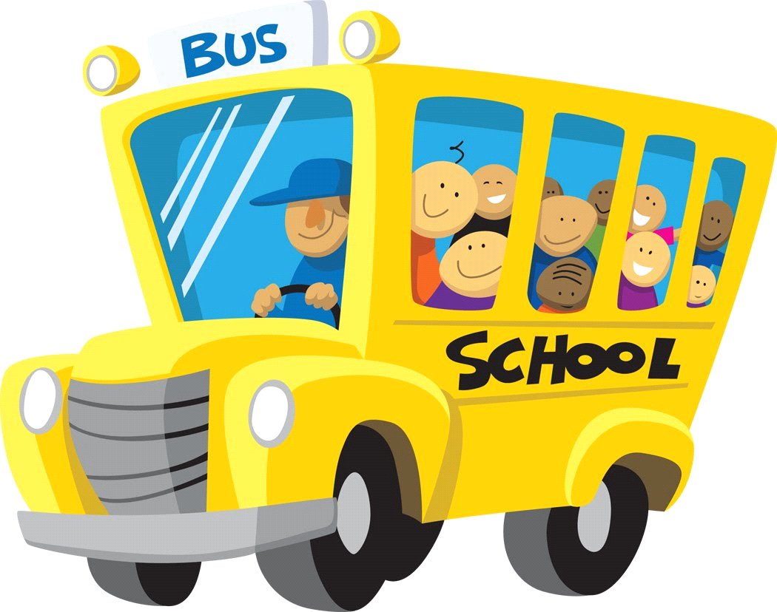

Start Date: _____________________________ Today’s Date: _________________

Student Name: _____________________________________________________________

Address: _____________________________________________________________

City: __________________________________State: _____________Zip: _____________

Birthdate: ______________________________Grade: _____________________________

Parents / Guardians Name: ____________________________________________________________

Phone Number: _________________________ Alt. Phone Number: ___________________

Does your child have any medical conditions that the driver should be aware of?

________________________________________________________________

Pick Up and Drop Off Location:

Family Dollar: 2 N. Baltimore Avenue. Mt Holly Springs
Pick up: 7:30 am
Drop off: 3:45 pm

In the event of an emergency on the bus we will contact the parents/guardian first. If we cannot get in touch with your parent/guardian, please list your emergency contacts below in the order of which they should be called.

Name: _____________________________________ Phone: ________________________________

Relationship to the student: ____________________ Alt. Phone: _____________________________

Name: _____________________________________ Phone: ________________________________

Relationship to the student: ____________________ Alt. Phone: _____________________________

GMCS Van: Mt. Holly Springs

