
REQUEST FOR TRANSPORTATION
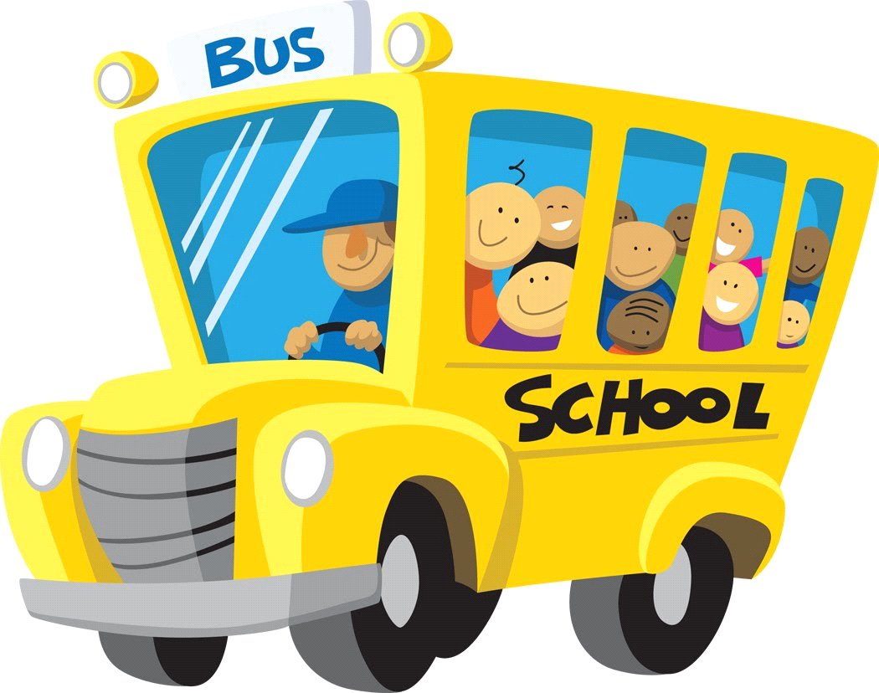

Start Date: _____________________________ Today’s Date: _________________

Student Name: _____________________________________________________________

Address: _____________________________________________________________

City: __________________________________State: _____________Zip: _____________

Birthdate: ______________________________Grade: _____________________________

Parents / Guardians Name: ____________________________________________________________

Phone Number: ___________________________ Alt. Phone Number: _________________________

Emergency Contact Information: (In the event of an emergency on the bus, we will contact the parents first.)

Name: ______________________________ Relationship to the student: ______________________

Phone Number: _______________________ Alt. Phone Number: ___________________

Does your child have any medical conditions that the driver should be aware of?

________________________________________________________________

BUS STOP LOCATIONS:

_____ Fairfield Stop – Liberty Worship Center (29 Carroll’s Tract Rd. Fairfield)

_____ Cashtown Stop – Cashtown Fire Dept. Hall (1111 Old Route 30 Cashtown)

_____ Gettysburg BEST After School (26 Springs Ave. Gettysburg) Students will be received by their employees.

_____ Babes In Arms Daycare (150 Hunterstown Hampton Rd. Gettysburg)

