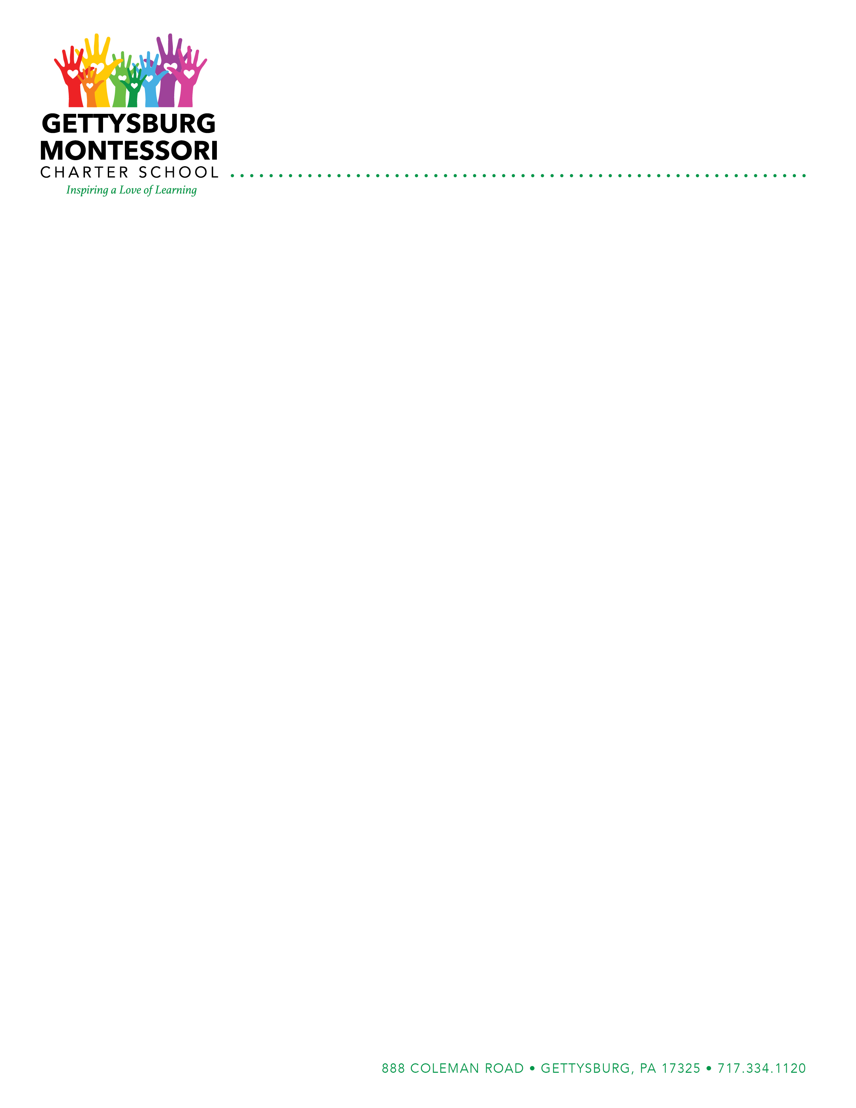
Non-Aerosol Topical Sunscreen Use
Parent/Guardian Consent Form

In October 2018, the Pennsylvania School Code changed to include parental permission for students to carry and apply sunscreen during the school day.
Sunscreen must be:
- Non-aerosol and FDA Approved
- Supplied by the parent/guardian
- Student name clearly written on bottle or tube
- Accompanied by a permission slip signed by the parent/guardian and the student
The student will not be permitted to carry sunscreen if they fail to follow school rules concerning its use. Sunscreen may not be shared with other students. Parent/guardian will be notified if the student does not demonstrate proper responsibility for their personal sunscreen.
Although staff can supervise the application of the sunscreen, each student must be able to apply their own sunscreen and the student is responsible for applying it when needed.
Students who are unable to self-apply sunscreen, and who need to have staff apply the sunscreen, must have an order from their primary care provider (PCP), along with parent/guardian permission – as with any other over the counter (OTC) medication. If your student is unable to apply sunscreen, contact the GMCS nurse.

Student Name: _____________________________________________________ Grade: _____________
Homeroom Teacher: ____________________________________________ School Year: ____________

To be completed by the Parent/Guardian:
I confirm that I am the parent/guardian of the student. I confirm that I understand the school is not responsible for ensuring that sunscreen is applied by the student. I confirm that the student has demonstrated that they are able to self-apply the sunscreen.
Parent/Guardian Signature: __________________________________________ Date: ________________

To be completed by the Student:
I confirm that I know the proper method of self-applying the sunscreen and that I know proper safety precautions for handling and disposing of it.
Student Signature: ___________________________________________________ Date: _______________

